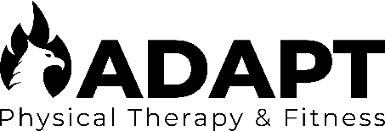
JOB TITLE: LEAD FITNESS MANAGER
SUPERVISOR: JACOB GRABOSKI
JOB TYPE: HYBRID
JOB SUMMARY: The Lead Fitness Manager is responsible for the following:
- Overseeing and managing the following programs: (estimated 8 hours/week)
  - Inclusive Fitness Training Program
  - Group Fitness Classes
  - Nutrition Coaching Program
  - Personal Training & Sports Performance Program
- Providing direct client services for the following programs: (estimated 20 hours/week)
  - Inclusive Fitness Training Program
  - Group Fitness Classes
  - Nutrition Coaching Program (optional – if holding active certification)
  - Personal Training & Sports Performance Program
- Developing content for the business website, blog, and social media pages (estimated 2-4 hours/week)
- Identifying and attending various community networking and/or sponsorship events (estimated 0-1 hours/week)
- Performing gym cleaning and sanitizing services (estimated 2 hours/week)
EMPLOYMENT STATUS & COMPENSATION:
- Hourly Employee: $28/hour
- Work Schedule: Up to 35 hours per week
- Health Benefits: Not eligible
- Retirement Benefits: Not eligible
- Holiday Time-Off: New Year’s Day, Memorial Day, Independence Day, Labor Day, Christmas Eve, Christmas Day
- Performance Bonus: Eligible for raises and end-of-year performance bonus
APPLICANT ELIGIBILITY:
- Bachelors Degree or higher
  - Preference given for Exercise & Movement Science, Public Health, Nutrition, and/or Therapeutic Recreation degree
- Strong skills in communication, organization, problem-solving, and documentation/writing required
- BLS/AED Certification is required
- Prior experience working with Excel, Word, Adobe, and Wix strongly recommended
INTERESTED APPLICANTS SHOULD SUBMIT AN APPLICATION AT WWW.ADAPTWISCONSIN.COM
https://www.adaptwisconsin.com/apply

